|  |  | | | |
| --- | --- | --- | --- | --- |
|  | |  | | |
| Project: | | Mobile Mech (MM) | | |
| Team No.: | | 4 | | |
| Class: | | CSE 3310; Fall 2024 | | |
| Module: | | Unified Modeling Language (UML) | | |
| Deliverable: | | UML Document – Increment I delivery | | |
| **Version:** | | **[1.0]** | **Date:** | **[9/26/2024]** |

Contributors:

Sujana Kabir  
Margaret Roche  
Patrick Williams  
Jonathan Hor

**Revision History**

| ***Version number*** | ***Date*** | ***Originator*** | ***Reason for change*** | ***High-level description of changes*** |
| --- | --- | --- | --- | --- |
| 1.0 | 9/26/2024 | Team#4 | Initial draft | Added UML diagram and short introduction |
|  |  |  |  |  |
|  |  |  |  |  |
|  |  |  |  |  |

TABLE OF CONTENTS

**1. Introduction and Project Overview 3**

**2. Project Context Diagram 4**

**3. UML Diagram 5**

3.1 UML Diagram: “System” 5

3.2 UML Diagram: “Registration and Sign-in” 6

3.3 UML Diagram: “User Profile” 7

3.4 UML Diagram: “Communication” 8

3.5 UML Diagram: “Mechanic profile” 9

3.6 UML Diagram: “Reporting” 10

3.7 UML Diagram: “Payment” 11

3.8 UML Diagram: “Appointment” 12

3.9 UML Diagram: “Search” 13

# 1. Introduction and Project Overview

The Mobile Mech App is an innovative Android application designed to connect users with professional mechanics, offering a convenient and efficient way to access automotive repair and maintenance services. Inspired by healthcare apps like ZocDoc or Teledoc that provide "on-demand" services, the Mobile Mech App aims to bring similar convenience to the automotive repair industry.

The android project will consist of 8 different components: Registration and Sign in, User Profile, Communication, Mechanic Profile, Reporting, Payment, Appointment, Search. When the user logs in to the application, they will be prompted to register or sign in. If they are an existing user, the user will simply sign in using their email and password. Otherwise the user will have to register. There will be both user and mechanic profiles so that both parties can have a bit of an overview. There will be ways of communication for the user with the mechanic. In the app, there will be an option to transact money from the user to the mechanic. Similar to ride apps, there will be reviews available of the mechanic so that the user can choose whom to contact best.

# 2. Project Context Diagram

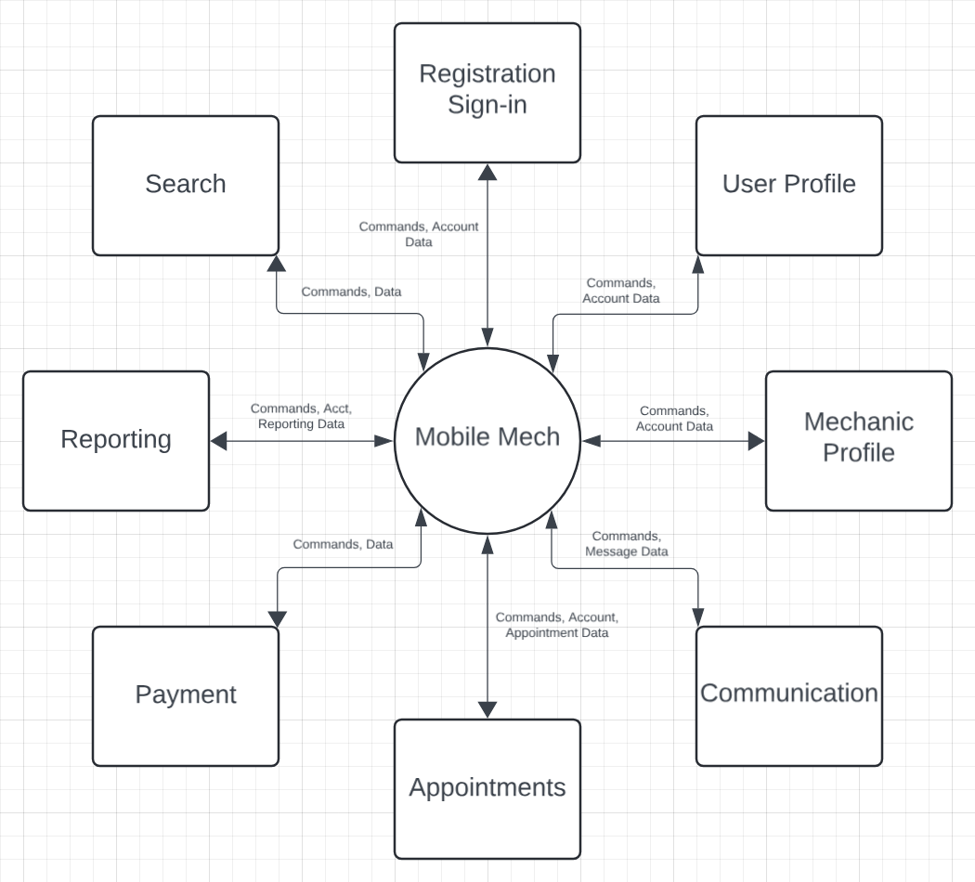

# 3. UML Diagram

## 3.1 UML Diagram: “System”

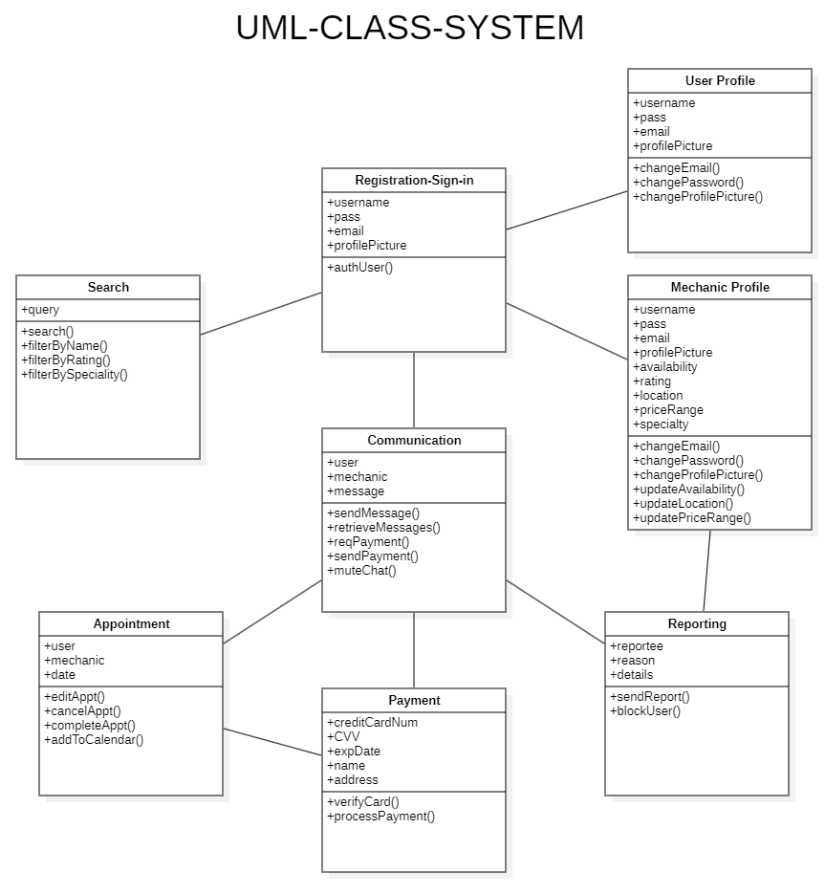

## 

## 

## 3.2 UML Diagram: “Registration and Sign-in”

## 

## 

## 3.3 UML Diagram: “User Profile”

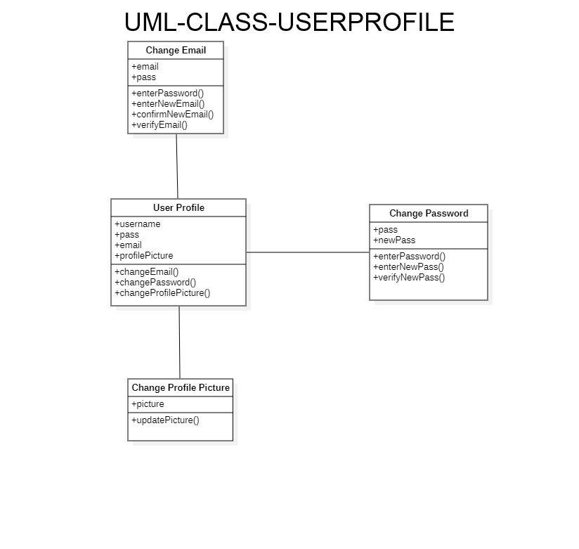

## 3.4 UML Diagram: “Communication”

## 

## 3.5 UML Diagram: “Mechanic profile”

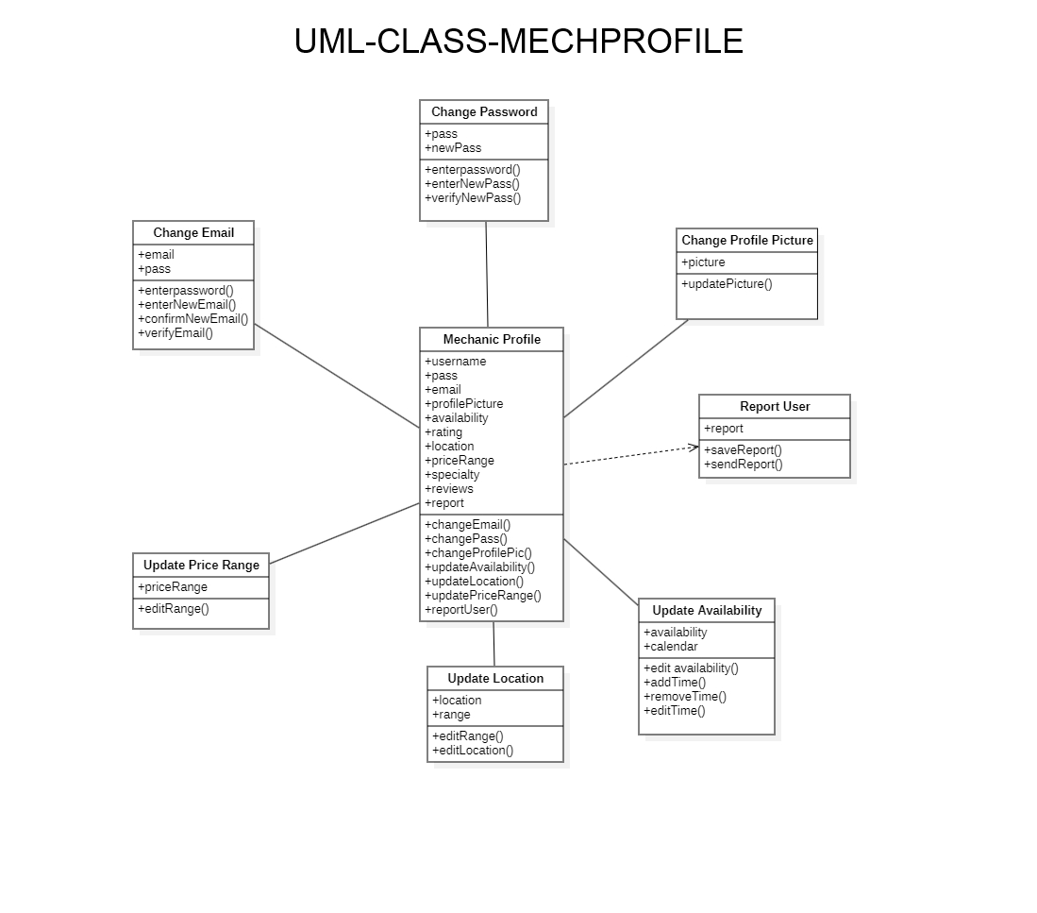

## 3.6 UML Diagram: “Reporting”

## 

## 

## 3.7 UML Diagram: “Payment”

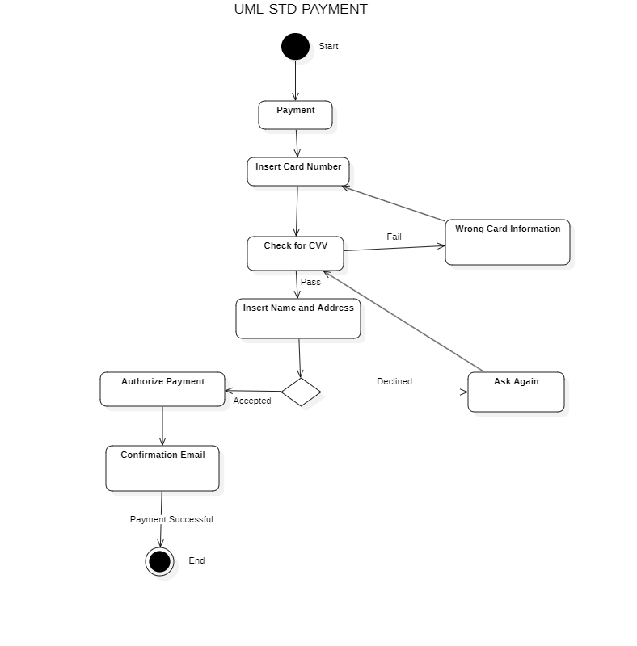

## 

## 3.8 UML Diagram: “Appointment”

## 

## 

## 

## 

## 

## 3.9 UML Diagram: “Search”

